Title of Your Work (14pt Times New Roman)
Member’s Names (11pt Times New Roman)
Affiliation, Country, e-mail (10.5pt Times New Roman)

Abstract
Here you write the overview of your product. The length of the abstract should be 200-300 words. In the beginning of the abstract, the subject of the paper should be stated clearly, together with its scope and objectives. Then, the methods, equipment, results and conclusions in the paper should be stated concisely in a sufficiently logical manner. (10pt Times New Roman)
Note: This is a sample template for proceeding. Please follow the format within two pages.
Background & Purpose
Here you explain the background, purpose and subject of your product. (10pt Times New Roman)

Concept & Idea
Here you explain the concept and idea of your product in detail. (10pt Times New Roman)
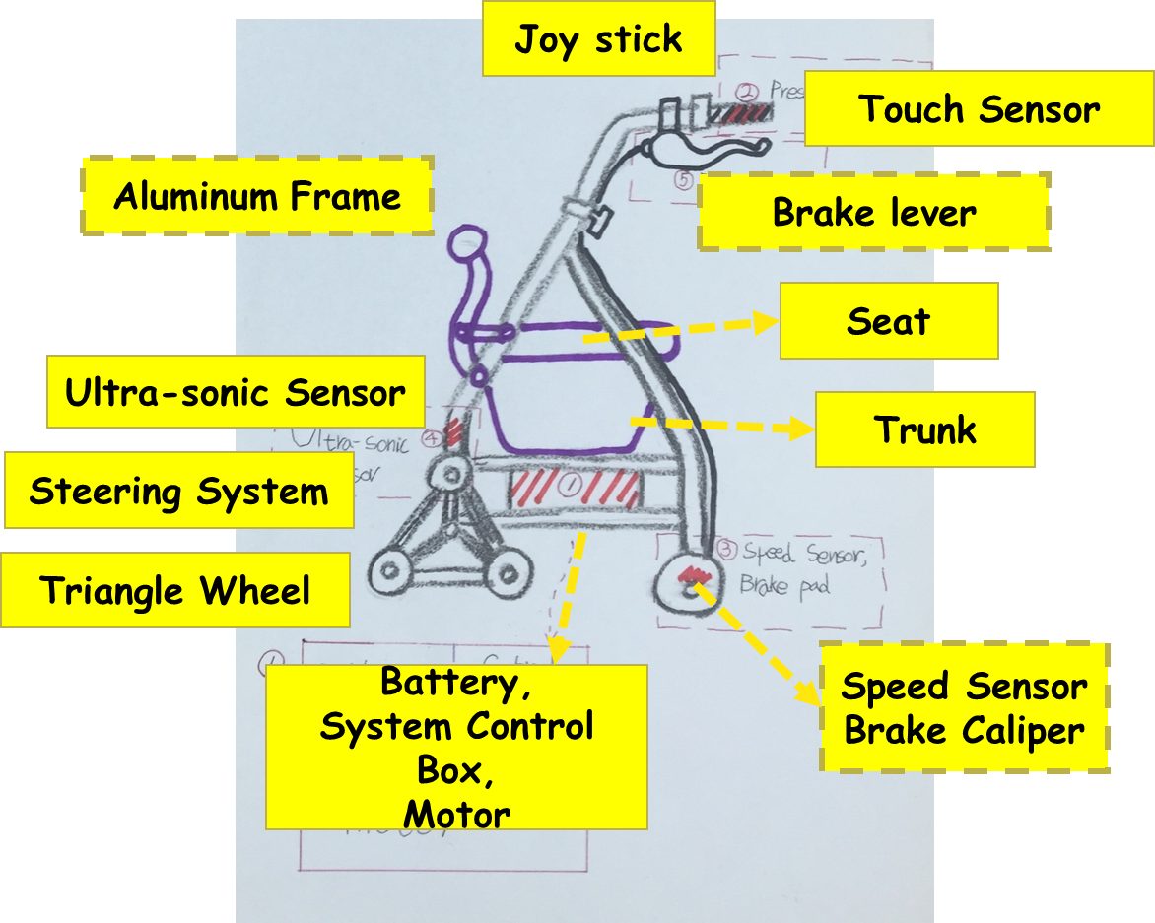
Fig.1 Example of drawing figure. (9pt, Times New Roman)

Design & Functions
Here you explain the design and function of your product in detail. (10pt Times New Roman)
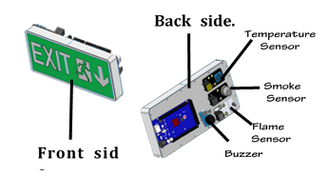
Fig.2 Design and functions.

Problems & Future work
Here you explain the problems which are still remained and the future work to complete your product. (10pt Times New Roman)

